
ALMAAREFA University
College of Applied Scineces
Department of Computer Science and Information Systems
Project Title

English: SmartRAD AI: Intelligent operational workflow optimization and case prioritization in x-ray radiology department

Arabic: SmartRAD AI: تحسين سير العمل الذكي وتحديد أولوية الحالات في قسم الأشعة السينية

Team members:
ID | Name
221220510 | Dayma muteb Alotaibi
221220460 | Layan Abdullah Abalkhail

Supervisor:

Dr. Nasriah Zakaria

A report submitted in part fulfilment of the degree of BSc in [Computer Science /Information Systems/ Health Information Systems
2025 – 2026

Abstract: 2
Chapter One: Introduction 3
1.1: Introduction: 3
1.2 Project Description: 3
1.3 Project Purpose: 4
1.4 Problem Statement: 5
1.5 The System Context View: 6
1.6 System Requirements: 7
1.8 Challenges: 9
1.9 Projection: 10
1.10 Ethical Considerations 11
Chapter Two: Literature Review 12
2.1: Background 12
2.2: Literature Review 13
2.3 The Existing Solutions 17
Chapter Three: System Architecture and Design 19
3.1 Introduction: 19
3.2 Methodology: 20
3.3 System Architecture 21
3.4 Structural model 22
3.5 Detailed System Architecture 27
3.6 User Interface 28
3.7 Quality Assurance 29
3.8 Acceptance Criteria 29
3.9 Future Consideration 30
Chapter Four: Experimental Setup and Configuration 31
4.1 Hardware and Software Setup: 31
4.2 Installation and Configuration: 32
4.3 Tools and Technologies Used: 34
4.4 System Training (for AI systems): 35
4.5 Testing and Validation: 36
4.6 Risk Analysis and Mitigation: 37
Chapter Five: Results and Discussion 38
5.1 Results: 38
5.2 Discussion: 40
5.3 Limitations: 40
Chapter Six: Conclusion 42
6.1 Summary of Work: 42
6.2 Lessons Learned: 43
6.3 Future Work: 44
References 46
Appendices 47
A1. Project Timeline 47
A2. Source Code Documentation 48
A3. User Manuals 48
A4. Additional Diagrams 48

Abstract:
Radiology department faces a continuous challenge in managing x-ray workflow that is due to for example high patient volumes, manual scheduling and lack of integration between hospital systems. So, cases often progress as slowly because operational data such as exam type, request time, scanner availability and radiologist workload are not benefiting fully to guide scheduling or case routing. This can result in bottlenecks, imbalanced workloads and can lead also to delay delivering results, especially when the urgent requests are combining or mixed with routine examinations. The lack of intelligent workflow supporting can lead to minimize efficiency, increases patient waiting time and fatigue both the staff and the resources.
SmartRAD AI is a web-based application designed to optimize X-ray operational workflows and support case prioritization. In SmartRAD AI, case prioritization is to organize and routing X-ray studies based on workflow parameters rather than clinical urgency. The system uses operational data such as request time, scanner availability, and radiologist workload to ensure that exams move through the process efficiently. For example, an emergency request is not delayed behind routine cases simply because of scheduling gaps, and radiologists receive a balanced distribution of studies. This approach improves throughput and resource utilization while leaving all medical decisions to clinicians. In this project, we will design and present SmartRAD AI as a modular application built with a Prediction Engine, Workflow Orchestration Engine, HL7 Listener, DICOM Processor, and a Dashboard Interface. The application will analyze real-time operational data such as exam type, request timestamp, modality subtype (CR/DX), acquisition time, device identifier, imaging room name, study status indicators, scanner availability and radiologist workload to automate routine workflow tasks and optimize case routing.

Chapter One: Introduction

1.1: Introduction:
The SmartRAD AI project is developed to enhance service quality and operational efficiency in radiology departments by intelligently a web-based Application that optimizes the X-ray workflow and scheduling process through Artificial Intelligence (AI) and predictive analytics. Focusing on X-ray imaging, which serves as the primary gateway for most radiology departments and remains the most performed and widely adopted imaging modality both clinical and emergency settings, the project improves workflow management and predictive capability to support healthcare providers and deliver greater value to patients. It introduces an AI-driven framework for intelligent case management and workflow optimization through intelligent case sequencing, enabling faster and more accurate scheduling and resource allocation. Ultimately, this project represents an essential step toward intelligent transformation within radiology departments, with the potential for future expansion across all imaging modalities, including CT, MRI, and others, to improve diagnostic speed, service quality, and overall operational efficiency.

1.2 Project Description:
SmartRAD AI is an intelligent web-based Application as external assistant layer alongside RIS/PACS without modify anything, which designed to improve radiology operations by enhancing workflow organization and case prioritization, with a dedicated focus on X-ray imaging، The most frequently performed modality and operational entry point in most radiology departments. The system improves scheduling accuracy and supports smoother case progression by analyzing real-time operational data such as exam type, request timestamp, scheduled appointment time, modality subtype (CR/DX), acquisition time, device identifier, imaging room name, study status indicators, scanner availability, and radiologist workload. These data elements are obtained from the Radiology Information System (RIS) through HL7 messages or APIs, while DICOM metadata is used to retrieve detailed imaging information directly from X-ray devices without modify the data on RIS the integration just read via approved interfaces and PACS is accessed in a read-only manner. Using regression-based predictive model, SmartRAD AI predicts scan duration and generates an operational urgency score that supports more effective case sequencing and resource allocation. Within the workflow orchestration and dashboard layer, the system also provides built-in case tracking and workflow reporting as an integrated function, producing periodic performance insights such as scan-duration trends, device utilization, and overall turnaround times to guide continuous operational improvement. In parallel, the prediction engine incorporates a continuous learning integrated function that refines its estimations over time by using newly collected operational data, which is stored in a dedicated database layer. This database ensures persistence of historical records, enabling scan-time predictions and workflow forecasting to adapt to changing patterns and load conditions. The overall architecture consists of five core components is Prediction Engine, Workflow Orchestration Engine, Dashboard Interface, HL7 Listener, and DICOM Processor, supported by a database layer that stores operational metadata and historical exam records. working together to ensure streamlined data flow, actionable operational insight, and a scalable foundation for future expansion into additional imaging modalities such as CT and MRI.

1.3 Project Purpose:
The purpose of the SmartRAD AI project is to improve X‑ray operational workflows in radiology departments by introducing a web‑based application that helps organize scheduling, directs how cases move through the workflow, and takes advantage of real‑time operational data. Current workflows suffer from manual scheduling delays, fragmented system integration, bottlenecks, and imbalanced workloads, all of which reduce efficiency and increase patient waiting times. SmartRAD AI helps to reduce these issues through its modular components, Prediction Engine, Workflow Orchestration Engine, HL7 Listener, DICOM Processor, and Dashboard Interface, which enable work together to improve efficient case routing, balanced workload distribution it’s mean improving tasks distribution more fairly between staff and machines, also improve seamless and reliable communication between hospital systems. By integrating HL7 and DICOM standards with predictive analytics and real‑time monitoring, the application ensures that urgent and routine cases are managed more effectively, resources are utilized efficiently, and staff are supported with useful, clear operational information. In general, the project aims to show clear improvements in how efficiently radiology departments handle X-ray workflow by reducing points where the workflow slows down, shortening patient waiting times, and improving the overall coordination of X‑ray services.

1.4 Problem Statement:
When we are exploring the issues in x-ray operational workflow the Radiology department faces challenges in managing x-ray workflow that hinder efficiency and timely patient care. We found several issues like scheduling delays which happen due to scheduling are often handled manually, this can lead to overlaps or long waiting times. For example, an emergency chest x-ray may be queued behind routine follow up exams, delaying urgent care. Second problem is workflow bottlenecks which are caused by high patient volumes that overwhelm the radiology department Especially during busy hours, dozens of x-ray studies can pile up in the worklist. Without smart routing urgent and routine cases are mixed making it harder to move critical studies forward quickly. This creates bottlenecks that cause slow down the entire process. The third problem we address is the imbalance in workload distribution across X ray rooms and technologists. Some rooms become overloaded with a high number of cases while others remain underutilized. This uneven distribution leads to longer waiting times, workflow delays, and increased operational pressure on the staff handling the busiest rooms. Finaly Limited use of real-time operational data, radiology department generate a large amount of operational data during x-ray workflow, such as scanner availability, exam acquisition times and study state updates, so that information is often not analyzed or acted upon in real time. As a result, scanners may sit idle or completed exams go unnoticed, wasting resources and cause also delaying reporting. for example, imagine a busy morning where a scanner finishes an exam but the system doesn’t show it as available so patient keep waiting and a completed x-ray is not fagged, both delays happen because real time data is not used.

1.5 The System Context View:
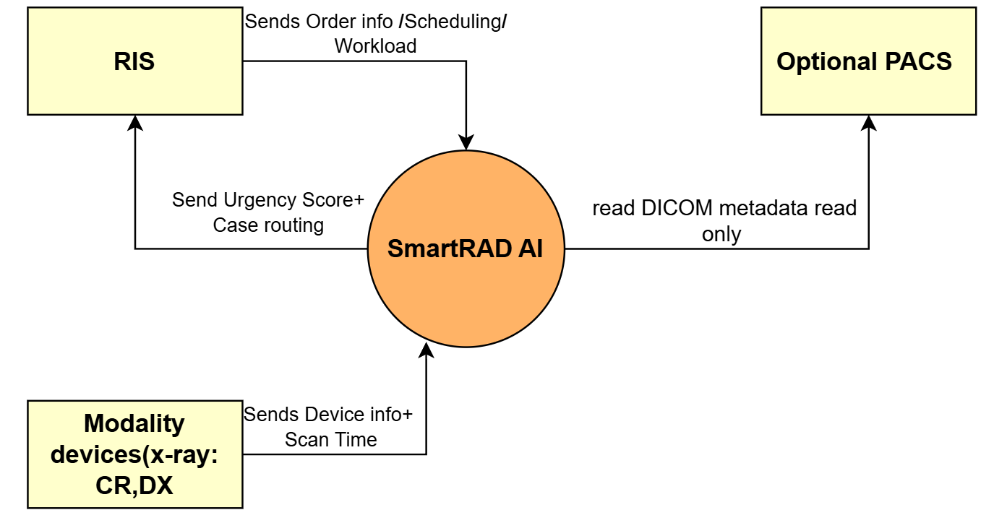
Figure1.5
SmartRAD AI seamlessly integrates with various components of the radiology workflow, including the Radiology Information System (RIS), modality devices like CR and DX. It connects to the RIS using HL7 ORM and ORU messages or through RESTful APIs. The System Context View includes only the external systems that exchange data with SmartRAD AI. For the X-ray workflow this includes the RIS, which provides order and patient information and the X-ray modality devices, which provide operational metadata such as timestamps and device identifiers. PACS may be included as an optional read-only source of DICOM metadata.

1.6 System Requirements:
This section outlines the essential requirements for SmartRAD AI, categorized into functional and non-functional aspects. These requirements define the expected capabilities, performance standards, and integration constraints necessary to achieve the system’s objectives of improve workflow in x-ray radiology departments.
Functional requirement is a statement of services the system should provide, how the system should react to a particular input and how the system should behave in particular situations. In our system SmartRAD AI functional requirements are:

-HL7 and DICOM metadata ingestion:The system integrates with the Radiology Information System (RIS) using HL7 standards to ingest scheduling and order-related operational data. It also retrieves DICOM metadata directly from X-ray modalities (DX/CR) to obtain imaging timestamps and modality subtype information. PACS may be used only as an optional, read-only source of DICOM metadata when direct modality access is not available.
DICOM metadata Extraction: The system shall extract operational imaging metadata directly from X-ray devices (DX/CR), including modality subtype, acquisition time, device identifier and imaging room information. Additionally, the system may retrieve high-level DICOM study metadata from PACS in a read-only manner, such as study status and availability. Only to support workflow monitoring when direct modality metadata is not available.
- RIS Order Data Ingestion: The system shall retrieve and integrate imaging order metadata for example exam type, request timestamp, scheduled appointment time, and study status from the Radiology Information System (RIS) through the HL7 Processor using HL7 messages or approved APIs. Ensuring accurate scheduling and seamless data interoperability.
- Predictive Case Scoring: The system shall generate an operational urgency score using a regression-based predictive model to support intelligent case prioritization and real-time workflow decision-making.
- Predict X-ray Scan Duration: The system shall estimate expected X-ray scan duration using operational metadata and historical acquisition patterns to support workflow forecasting and room utilization planning.
-Workflow Orchestration: The system shall dynamically routing and prioritization of X-ray cases based on urgency scores, device occupancy, and radiologist workload distribution to intelligently sequence cases. By balancing scanner usage and minimizing delays, it ensures that each case is directed to the most suitable device and resource at the right moment. This optimization enhances throughput and maintains consistent workflow efficiency throughout the department.
-Real-time workflow dashboard: This function provides real time dashboard that displaying waiting cases, active devices, device status and availability, average waiting time, system load, and workload indicators. The dashboard shall also present detailed case queues and performance analytics to enable radiology staff to monitor operations, detect workflow delays and maintain continuous service efficiency.
Non-Functional requirements are:

-Performance
The system must provide fast real-time predictions and responsive dashboard updates with minimal delays to support daily radiology workflow.

-Reliability & Availability
The system must remain stable and consistently available under high workload, with error-handling mechanisms that prevent workflow interruptions.

-Interoperability (HL7 & DICOM)
SmartRAD AI must integrate smoothly with the Radiology Information System (RIS) using HL7 messages to receive scheduling and order-related operational data. The system shall also extract DICOM metadata directly from X-ray modalities (DX/CR) to obtain acquisition timestamps, modality subtype, and device information. PACS may be used only as an optional, read-only source of high-level DICOM study metadata when direct modality access is not available
-Scalability
The system architecture should support adding more X-ray devices, users and future expansion into additional imaging modalities such as CT and MRI.

-Security & Compliance
The system must protect all clinical and operational data using secure access, authentication and encryption, and comply with healthcare data policies.

-Maintainability
The system should follow modular design to allow easy updates, debugging and long-term evolution.

-Usability
The interface should be simple and support both Arabic and English, with minimal training needed for staff.

1.8 Challenges:
-Collecting real data to train the model is a major challenge as data is considered sensitive and protected by strict privacy regulations in the radiology department.
-Integration with Radiology Systems: The system connects with existing radiology systems (RIS and PACS) to pull scheduling and operational data required for accurate and real-time predictions.
-Data and Metadata Inconsistency: Incomplete or non-uniform DICOM metadata across X-ray devices, especially older ones limit the model’s ability to generate accurate predictions.
-Workflow Complexity: Managing and sequencing X-ray cases dynamically across multiple devices requires a robust logic engine capable of adapting to real-time changes in workload and device availability.
-Scalability: The system should remain scalable to handle larger datasets, more users, and future imaging modalities without requiring significant redesign.
-User Trust & Adoption: Radiologists and technicians may be hesitant to rely on AI-based prioritization instead of traditional manual judgment, requiring effective user training and gradual adoption.

1.9 Projection:
Chapter 1 phased timeline (2 weak)

Phase 1 (1-3 days): In this phase we are planning to start writing for an overview of the project which is the abstract, then writing the introduction, we also describing our project then finally the project purpose.

-Introduction
-Project description
-Project Purpose

Phase 2: Problem& context analysis (4-6 days): In this phase, we focus on identify the problem statement, detailing the core issues that the project seeks to address. It will also include a system context view, illustrating how various elements interact within the external system in the hospitals that deal with us e.g. RIS, PACS, modality devices x-ray:CR/DX.

-Problem statement
-The system context view

Phase 3 Project Requirements and challenges (7-9): In this phase, the project requirements will be defined, covering both functional and non-functional aspects. This section will also identify potential challenges that may arise during the project lifecycle, setting the stage for strategic planning.

-Functional requirements
-Non-functional requirements
-Challenges

Phase 4 Planning and ethics (10-14): This final phase will emphasize ethical considerations related to the project. It will address how to ensure adherence to ethical standards throughout the project's execution without including a projection.

-Ethical considerations.

1.10 Ethical Considerations
1-Data Handling & Anonymization: SmartRAD AI follows strict ethical guidelines to protect patient privacy and confidentiality. All patient-related information used for AI modeling or workflow prediction is fully de-identified before processing. The system relies only on anonymized operational and imaging metadata, ensuring that no personal identifiers are stored, accessed, or used at any stage. This approach maintains patient safety while enabling responsible use of data for workflow optimization.
2-Privacy & Security: Safeguards sensitive medical information against unauthorized access or misuse, Access to SmartRAD AI is restricted to authorized healthcare professionals through secure authentication. All data transfers between components (HL7/DICOM interfaces, dashboard, and database) are encrypted using healthcare-standard security protocols.
3-Fairness & Bias Prevention: SmartRAD AI should ensure that its training data does not come disproportionately from one type of X-ray case or a single device. The system must use mixed and standardized operational data, so it doesn’t favor a certain pattern. This keeps the predictions balanced and fair across all X-ray requests.
4-Human Oversight: SmartRAD AI supports decision-making but does not replace radiologists. All prioritizations and workflow suggestions must remain reviewable and overridable by authorized medical staff to prevent over-reliance on the system.
5-Accountability & Responsibility: SmartRAD AI does not make clinical or diagnostic decisions; it only supports workflow routing. Final responsibility for case prioritization and radiology workflow remains with authorized staff. This ensures that the system assists operations without replacing human judgment.
6-Regulatory Compliance: SmartRAD AI must handle, store and process patient and operational data in compliance with hospital policies and data-protection regulations, while adhering to DICOM and HL7 standards to ensure safe and compliant interoperability.

Chapter Two: Literature Review

2.1: Background
Radiology plays a central role in modern healthcare, providing essential imaging needed for diagnosis and clinical decision-making [1]. Among all imaging modalities, X-ray is the most frequently performed exam and serves as the primary entry point for most radiology cases due to its speed, availability and wide clinical use. Because of this high demand, X-ray workflow efficiency directly affects patient movement, waiting times and overall departmental performance [2]. In the Radiology department there’s Several basic terms are commonly used x-ray modality types such as CR and DX, radiology information systems (RIS) for Managing radiology requests and scheduling examinations, PACS for storing and retrieving images, and communication standards such as HL7 and DICOM for interoperability but for PACS in the project idea is PACS may be used only as an optional read-only source of DICOM metadata when direct modality access is not available. [3]. Operational metadata refers to Key terms such as Request timestamp, Acquisition timestamp, Scanner availability, Technologist workload, study status indicators are critical for monitoring workflow [3]. Despite its central role in radiology, X-ray workflow still faces several operational issues some of these issues in radiology department like delays in handling of x-ray requests, slow movement of cases through the workflow also cases not progress forward on real time, uneven workload across devices and staff, ongoing reliance on manual scheduling [4]. SmartRAD AI addresses these operational issues by using real-time workflow data to organize how X-ray cases move through the process more efficiently. The system helps reduce delays by identifying when devices are free, supports smoother case progression through automated sequencing, and distributes workload more fairly and evenly across radiologists and X-ray rooms. By giving a clearer view of request timing, scanner availability, and staff capacity.

2.2: Literature Review
Reviewed Works

- Article title1: Artificial intelligent Applications for workflow, process optimization and predictive analytics (Laurent Letourneau-Guillon, Daivd Camirand, Francois Guilbert, Reza Forghani, 2020).

- Article title2: Operational Optimization in Radiology: An Intelligent Information Management Platform Significantly Enhances Workflow Efficiency and User Satisfaction) Jicheng Fang, Guang Zheng, Jian Feng, Longbiao Cai, Jing Zhang, Qiuxia Wang, 2025).

- Title3: OmegaAI Cloud-native Unified Imaging Platform Developer: RamSoft Inc. (Medical Imaging Software Company)2023.

- Title3: Critical Care Suite for Chest X-ray Interpretation and Workflow Optimization Developer: GE Healthcare (Radiography & AI Solutions Division) 2019.

Introduction
Those academic research and industry applications show how Artificial Intelligence can improve radiology operations. The first article focuses on how artificial intelligent can improve radiology operations by using predictive analytics, workflow optimization and integration with hospital systems. Second paper show how dynamic information platform can enhance workflow efficiency through like self scheduling, queue monitoring, automated resources allocation and dashboard. OmegaAI is developed by RamSoft in 2023 which is a cloud based platform that simplifies the scheduling, image storage, viewing and reporting for large hospital and technology networks. GE Healthcare Critical Care Suite is an on-device AI tool built into mobile X-ray units that detects urgent chest findings right at the time of acquisition, helping ICU and emergency teams respond more quickly. Together, these applications show how industry solutions can improve radiology operations.

Key point:
- Artificial Intelligent Applications for Workflow, Process Optimization and Predictive Analytics confirm Artificial Intelligent role in workflow efficiency, case routing, workload distribution and safety noting that workflow optimization faces less barriers than the diagnostic AI.

- Operational Optimization in Radiology: An Intelligent Information Management Platform its shows the practical gains through self-scheduling, real-time queue monitoring, automated allocation and dashboards. Improving communication and reducing delays.

- OmegaAI is built as a cloud-based radiology platform that brings scheduling, image viewing, and reporting into one unified system, making it easier for large hospitals and teleradiology networks to manage their work from a single place. It focuses on centralizing access and removing the need for local installations.

- GE Critical Care Suite designed specifically for chest X-rays in critical-care settings. It automatically detects urgent findings right after the image is taken and helps clinicians identify life threatening conditions faster especially in ICUs and emergency rooms.

Problems we found

The research papers identified that main problem like bottlenecks in radiology such as scheduling delays that make the patient flow slow, uneven case routing that leaves some radiologist overloaded while other is underutilized, poor use of resources that waste staff time and even the equipment, incomplete patient histories that make the decision making harder and missing of communication among staff that make coordination disrupts. OmegaAI faces a basic workflow challenge in radiology, many departments still rely on multiple disconnected systems one for scheduling and another for images and for reports. This fragmentation slows down the workflow and makes it harder to track studies efficiently especially in large hospitals with high imaging volumes. So, the core issue here is operational keeping the workflow smooth when information is scattered across separate platforms. We explore on GE Critical Care Suite that have a very different problem, in emergency and ICU settings chest X rays often pile up in the reading queue and critical cases may wait too long because prioritization is manual. Without a system that flags urgent findings the moment the image is captured, life-threatening conditions like pneumothorax can be detected later than they should. The main issue here is delayed identification of critical abnormalities due to workload pressure and manual triage.
Methodes they used to solve similar problems

The first paper Artificial intelligent Applications for workflow, process optimization and predictive analytics, the researchers propose predictive models to anticipate exam times and workloads, automated case prioritization and routing to ensure urgent studies reach radiologists quickly, and stronger integration with hospital information systems. The second study Operational Optimization in Radiology: An Intelligent Information Management Platform Significantly Enhances Workflow Efficiency and User Satisfaction is implemented a dynamic information management platform with tools such as self-scheduling that allowed staff to manage appointments more efficiently and reduce delays, digital signatures sped up documentation and ensured secure approvals without paper bottlenecks, automated resource allocation helped distribute equipment and staff based on real-time demand, minimizing idle time and improving utilization, real-time monitoring dashboards provided live visibility into queues, workloads, and exam progress, enabling faster responses to problems. These methods collectively demonstrate how AI and intelligent platforms can support radiology departments in achieving smoother, safer, and more efficient workflows. OmegaAI addresses workflow issues by unifying RIS, PACS, and VNA into one cloud platform. Reducing fragmentation and making scheduling, viewing and reporting flow more smoothly. It also uses standards like DICOM and HL7 to keep data consistent across systems. GE Critical Care Suite solves its problem through on-device AI that analyzes chest X-rays immediately after they’re taken. If a critical finding appears the system flags it in PACS so radiologists can review it sooner.

Gap Analysis

The academic studies on radiology workflow remain mostly conceptual or limited to pilot projects, meaning they have not yet been fully deployed in clinical practice. OmegaAI fills gaps related to fragmented radiology workflow by combining scheduling, image viewing, reporting and storage into one cloud system but does not prioritize studies based on operational parameters such as timestamps, scanner availability or workload balancing across radiologists or devices. While GE Critical Care Suite addresses the gap of delayed detection in critical-care environments by adding AI triage directly to the x-ray device but does not handle workflow routing, scheduling, operational prioritization or workload distribution. its scope limited to clinical triage for chest x-rays. Finally taken together, these gaps show that while artificial intelligent and intelligent platforms have improved certain aspects of radiology operations, unresolved challenges remain in real-time prioritization, workload balancing and orchestration across different modalities. These challenges form the foundation for SmartRAD AI, which aims to deliver a more complete solution design to x-ray operational workflow and reduce workflow bottlenecks, balance radiologist workloads, improve resource utilization and ultimately demonstrate measurable efficiency gains in radiology departments.
Conclusion
Finally, research papers confirm that radiology departments face ongoing workflow bottlenecks, inefficiencies and safety risks due to reliance on outdated manual processes and fragmented systems. While proposed solutions such as predictive analytics, automated routing and smart platforms show promising signs they remain either theoretical or partial. SmartRAD AI builds on these foundations by integrating predictive engines, workflow management and real-time monitoring into a unified solution, providing tangible improvements in workload balance, efficiency, communication and patient safety. OmegaAI also demonstrates how an integrated radiology platform can facilitate operations in large hospitals by consolidating scheduling, imaging, storage and reporting into single system. This helps improve organization, but it does not address day to day operational issues such as case flow, workload balance or real-time routing within radiology workflow. while GE Critical Care Suite focuses on something different. It supports emergency and ICU teams by detecting critical findings immediately at the point of imaging.

2.3 The Existing Solutions
In today’s radiology landscape, several AI tools are already being used to improve imaging workflows. We explore OmegaAI (RamSoft) which is a powerful enterprise platform that manages multiple imaging modalities and prioritize cases based on clinical urgency. Critical Care Suite (GE Healthcare) takes a different approach, embedding AI directly into X-ray systems to detect urgent findings like pneumothorax and provide triage alerts. Both solutions show how AI can enhance patient safety and streamline clinical processes. But what they don’t do is organize or route X-ray studies using workflow parameters such as request time, scanner availability, or radiologist workload. This is where SmartRAD AI comes in and filling the gap by focusing on operational efficiency, balancing workloads, and reducing bottlenecks in X-ray departments.

This Table shows the compression between our system and other two systems:

Future/ capability | SmartRAD AI | OmegaAI  (RamSoft) | Critical Care suite  (GE Healthcare)
Workflow Prioritization | Its routes studies using operational data such as request time, scanner Availability | It prioritizes cases based on clinical urgency, not workflow parameters | Focus on urgent finding for example pneumothorax so its not workflow parameters
Workload Balancing | Actively distribute cases to avoid bottlenecks and balance workloads | No mechanism to balance workloads across radiology | No mechanism to balance workloads across radiology
X-ray Focus | Design specifically for x-ray operational workflow optimization  Operational focus | Is broad, covering multiple modalities but not specialized for x-ray workflows. | Also, its design for x-ray but is focused on clinical which detect urgent finding directly on GE x-ray systems.
Operational data use | leverage real time operational data to drive prioritization decision. | Dose not use these operational parameters for prioritization. It uses pathology driven prioritization. | Dose not use, it uses AI detection for pathology triage
Modular design | Build with modular components (Prediction Engine, Workflow Orchestration, HL7 Listener, DICOM Processor, Dashboard). | Instead of modular component its integrate RIS and PACS AND VNA. | Embedded into GE hardware. Instead of modular architecture, it’s tightly integrated with GE’s Definium X-ray systems.
Accessibility | is flexible and vendor-neutral, making it practical for small hospitals, clinics, and departments with limited resources | Best suited for large hospitals and teleradiology providers. Requires enterprise-level resources. | Accessible mainly to GE customers. Tied to GE’s ecosystem, limiting use in mixed-vendor departments.

Chapter Three: System Architecture and Design

3.1 Introduction:
This chapter presents technical foundation and implementation detailed of SmartRAD AI, its starts by explaining what the methodology we will use to guide its design and development. Following by an overview of system architecture and its structural model. Then going into the details of each system component including what the component functionality, interfaces and the interactions. Also, user interfaces and quality assurance measures that ensure reliability. Finally, the acceptance criteria and future consideration in this chapter are defined to evaluate the system performance and how SmartRAD AI can be enhanced and scaled in the future years.

3.2 Methodology:

1. Agile development is an iterative software methodology that emphasizes flexibility, collaboration and continuous improvement. It breaks the work into short cycles called sprints, which allowing teams to deliver incremental updates, gather feedback and adapt quickly to changing requirements. SmartRAD AI will use Agile to ensure the application evolves smoothly with features refined step by step to meet operational workflow needs in x-ray radiology department.
2. Predictive analytics applies statistical model and machine learning technique to forecast future outcomes based on historical and real-time data. By identifying patterns and trends its enables proactive decision-making and resource planning. SmartRAD AI will implement predictive analytics using regression-based predictive model to estimate scan durations, generate urgency scores and forecast workload distribution which supports more efficient scheduling and case prioritization.
3. Standards-based interoperability ensures that healthcare systems can exchange data seamlessly using established protocols such as HL7 and DICOM. This approach avoids proprietary barriers and guarantees compatibility across diverse IT infrastructures. SmartRAD AI will use standards-based interoperability to connect with existing radiology systems, enabling smooth data flow without requiring modifications to RIS or PACS and PACS may be used only as an optional, read-only source of DICOM metadata when direct modality access is not available.
4. Operational workflow optimization focuses on improving efficiency, reducing delays and maximizing resource utilization within organizational processes. It involves analyzing performance metrics, identifying bottlenecks and implementing strategies for continuous improvement. SmartRAD AI will use workflow optimization to streamline X-ray operations, enhance scheduling accuracy and provide actionable insights into turnaround times and device utilization.

3.3 System Architecture
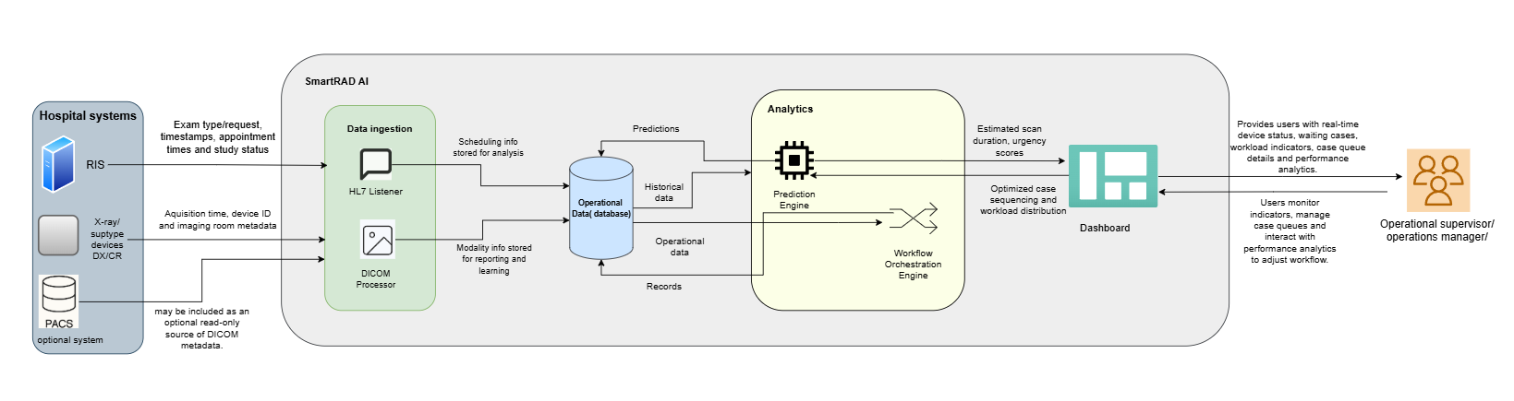 Figure3.3
This diagram shows how SmartRAD AI processes hospital imaging data to support radiology workflow. It begins with RIS, PACS is represented as an optional, read-only external system used only if DICOM metadata is retrieved from PACS instead of directly from the X-ray modality. And CR/DR devices sending exam requests and metadata. The HL7 Listener and DICOM Processor ingest this data and store it in the operational database. The Prediction Engine and Workflow Orchestration Engine then analyze the data to generate scan estimates and optimize case sequencing. The users included are the Operational Supervisor and the Operations Manager as they actively interact with the SmartRAD AI dashboard and trigger system processes. These insights are displayed on the dashboard giving users real-time tools to manage priorities, monitor performance and improve turnaround times.

3.4 Structural model
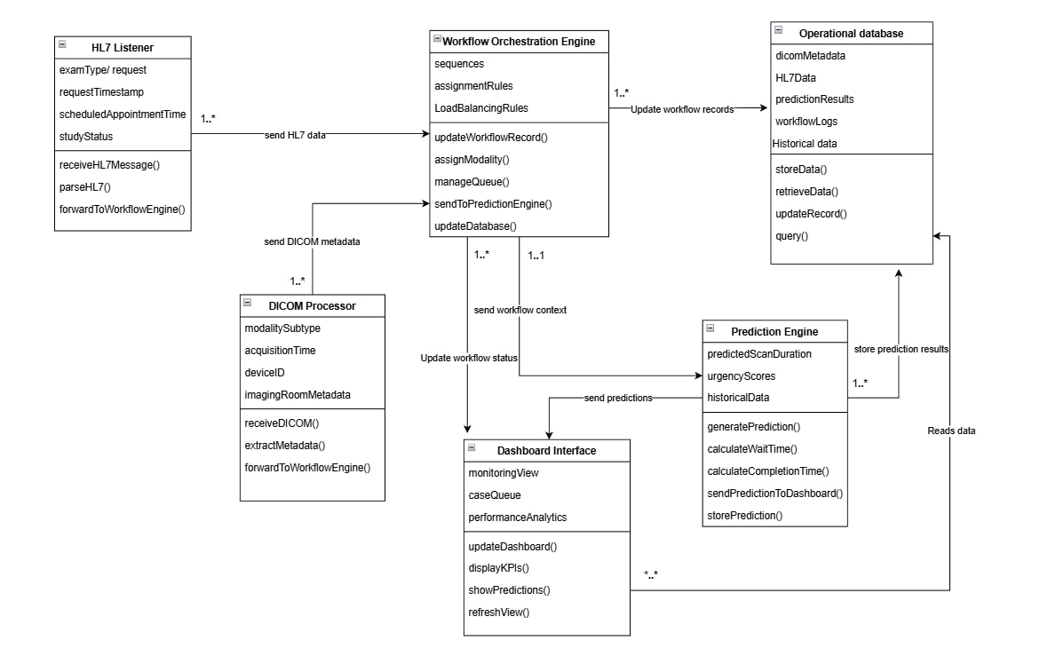

Figure3.4
This class diagram illustrates the core architecture of SmartRAD AI operational workflow system. It begins with the HL7Listener, which receives exam orders and parses HL7 messages. These orders are forwarded to the Workflow Orchestration Engine, which manages queue logic, modality assignment, and workflow updates. The DICOM Processor handles incoming imaging files, extracts metadata and feeds into the Workflow Engine. The Workflow Engine then sends context to the Prediction Engine, which calculates scan duration, urgency scores, and expected completion time. These predictions are stored and sent to the Dashboard Interface, which displays real-time case queues and performance analytics. All data HL7 orders, predictions, logs, and historical records are stored in the Operational Database, which supports both system updates and dashboard queries. The Dashboard Interface also feeds back into the Workflow Engine to update status and trigger actions.
Data Flow diagram (DFD):
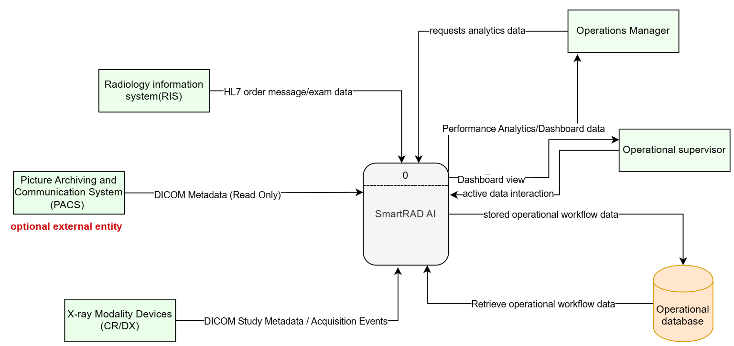
Figure3.5
A Data Flow Diagram (DFD) is a visual model that shows how information moves through a system including where data comes from, how it is processed and where it ends up. We chose DFD because our system integrates with hospital system with RIS and PACS is represented as an optional external entity that provides read-only DICOM metadata to the system. This metadata is used only when direct access to the modality device is not available, and no data is sent back to PACS. Not modifying on RIS and PACS itself so it’s important to show how information flows between them. In our DFD the central process is SmartRAD AI, which receives exam orders from the RIS and DICOM metadata from DX/CR X-ray modalities. The external entities that interact with the SmartRAD AI system are Operational Supervisor and Operations Manager, which request dashboard and analytics data to monitor workflow and performance. SmartRAD AI processes incoming data from external systems, updates the workflow state and stores all operational information in the Operational Database. The system then retrieves this stored data whenever it needs to generate dashboard views, workflow indicators or analytics.

Component diagram:
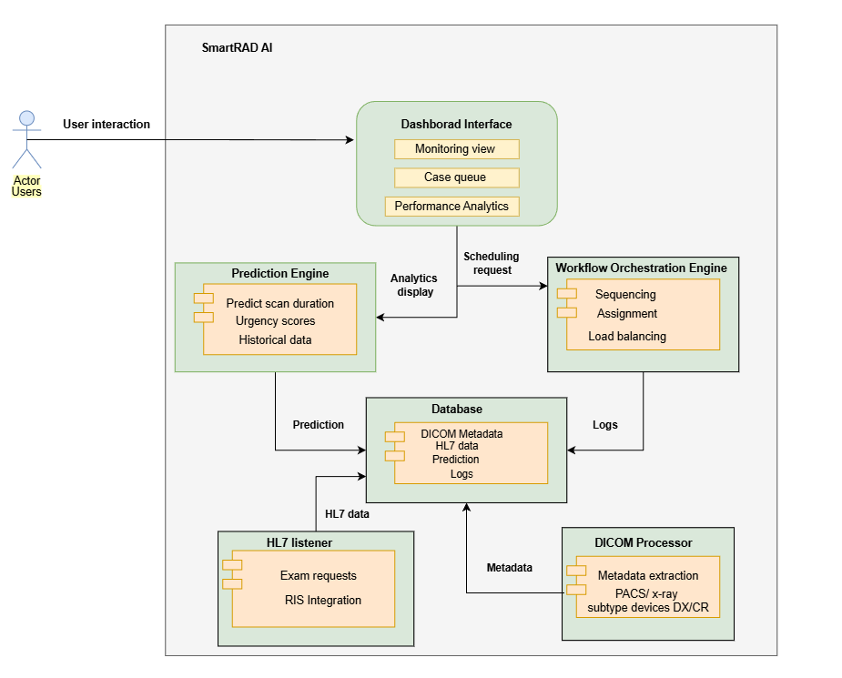
Figure3.6
This the structural model of SmartRAD AI that shows the internal components that handle data ingestion, prediction, workflow orchestration and user interaction. It includes modules like the HL7 Listener and DICOM Processor for receiving hospital data, a central database for storage and learning and engines for prediction and workflow optimization. The dashboard interface connects these outputs to operational supervisor and operational manager which enabling real-time monitoring and decision support.

Entity Relationship diagram (ERD) for Database:
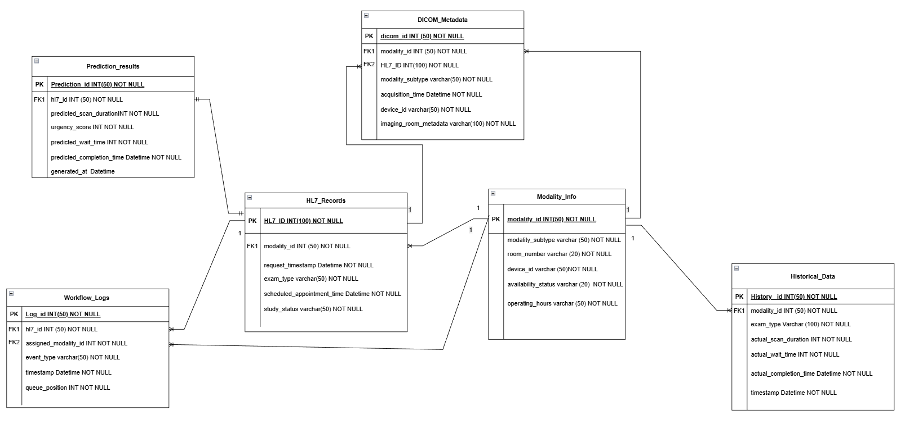
Figure3.7
An Entity-Relationship Diagram (ERD) shows the main data entities in a system and how they are connected. We use an ERD because SmartRAD AI handles many types of operational data HL7 orders, DICOM metadata, workflow logs, predictions and modality information. Soi t’s important to clearly show how these data tables relate to each other. In our ERD, Modality Info, HL7_Records, DICOM_Metadata, Workflow Logs, Prediction Results and Historical Data are the core entities. Modality Info Stores details about each X-ray machine (DX/CR), such as type, room and availability. While HL7_Records Contains exam order information received from RIS, including exam type, timestamps and patient workflow details. DICOM_Metadata Holds technical dicom metadata extracted from DICOM files, such as modality subtype, acquisition time and device information. Workflow Logs Tracks every workflow event (arrival, start, completion, queue updates) for each exam in real time. Prediction Results Stores the AI-generated predictions like scan duration, urgency score and expected completion time for each exam. While Historical Data Keeps past performance and timing data used to improve prediction accuracy over time. Together, the ERD shows a structured data model that supports SmartRAD AI workflow, prediction and dashboard features.
Use case diagram:
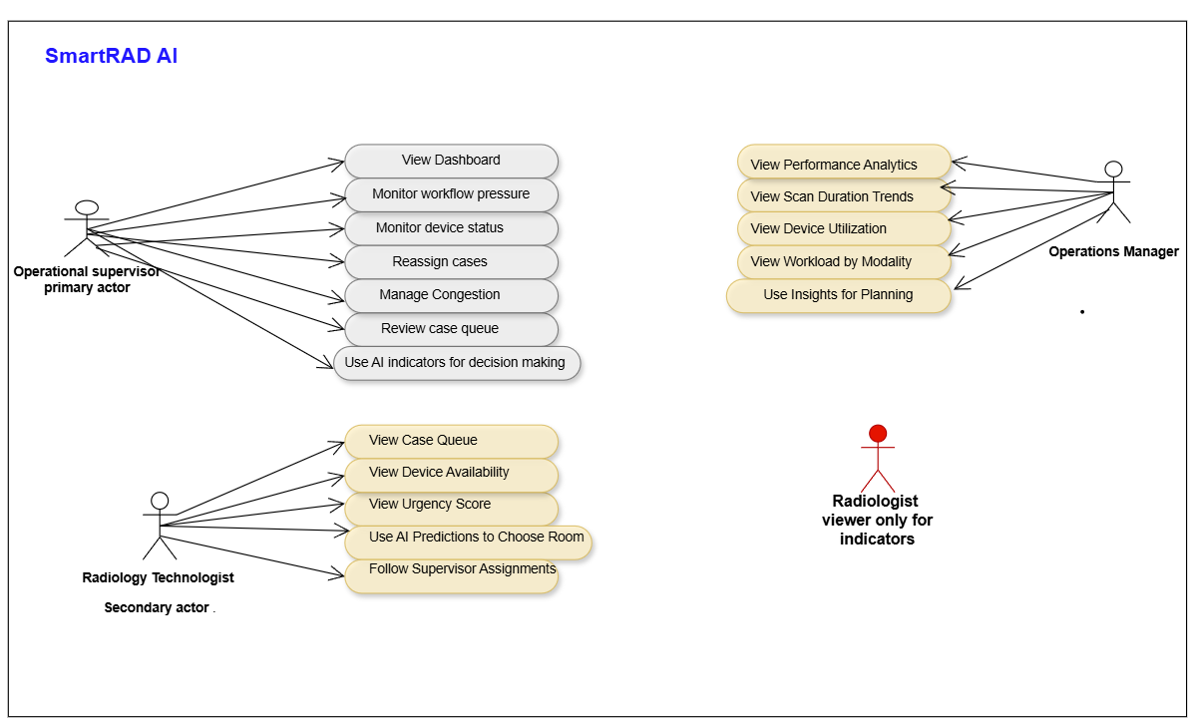
Figure3.8
This Use Case Diagram illustrates the SmartRAD AI system, where each actor is associated with specific use cases that represent their operational roles inside the system. The Operational Supervisor is the primary user, relying on the system’s dashboard, workflow pressure indicators, and device status to manage congestion and reassign cases in real time. The Radiology Technologist uses the case queue and AI-generated urgency, and duration estimates to choose the most suitable room and follow operational decisions efficiently. The Operations Manager interacts with the system mainly for performance analytics, using trends and utilization data to support long-term planning. The Radiologist may view indicators but is not considered an active system user.

3.5 Detailed System Architecture
This section will explain the main components of SmartRAD AI and their functionality, interfaces and interactions within the system.
- The HL7 Listener is responsible for receiving real-time operational data from the Radiology Information System (RIS), such as exam requests, timestamps, study status, and scheduling information. This data represents the main trigger for workflow updates inside the system.
- The DICOM Processor reflects actual imaging activity by handling technical metadata from X-ray devices, such as acquisition timing and device identifiers, supporting accurate workflow tracking and timing awareness.
- The collected data is then processed by the Prediction Engine, which analyzes historical and real-time operational parameters to estimate scan duration and generate an operational urgency score. These predictions are focused on workflow efficiency and do not involve any clinical interpretation.
- The Workflow Orchestration Engine uses the prediction outputs, along with device availability and workload indicators, to organize case movement and prioritize studies within the operational queue. This component ensures smoother case progression and balanced resource utilization.
- In the end the Dashboard Interface provides users with a clear view of the current workflow status. It displays real-time updates, case tracking information, and operational indicators that support monitoring and decision-making at the operational level.
The five core components are supported by an operational database layer that stores exam metadata and historical records. This database enables continuous learning for the prediction engine and provides the foundation for workflow reporting and performance insights. Together, these components form an integrated architecture that enables SmartRAD AI to collect data, generate predictions, orchestrate workflow and present actionable operational insights in a unified web-based system.

3.6 User Interface
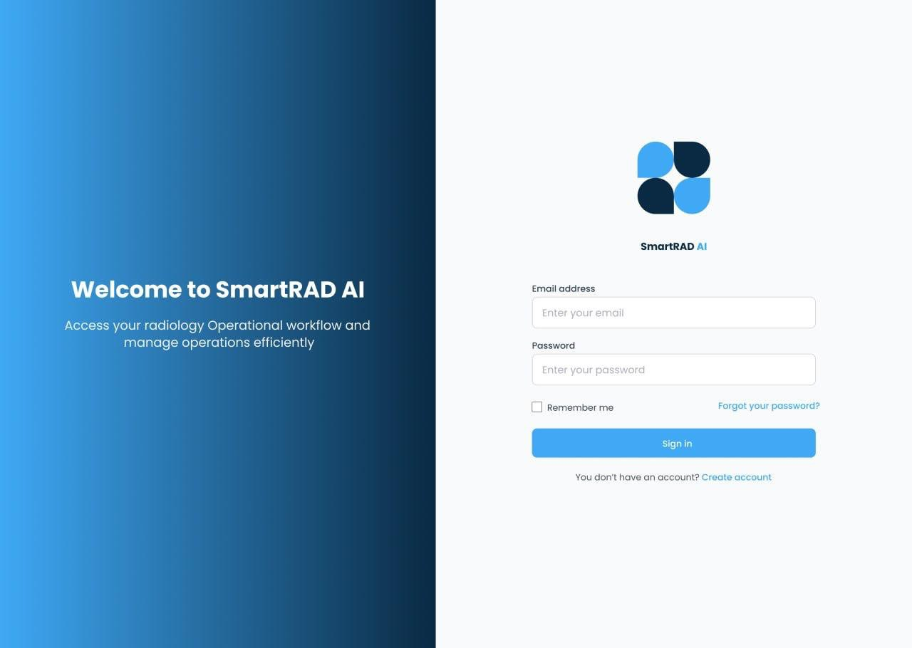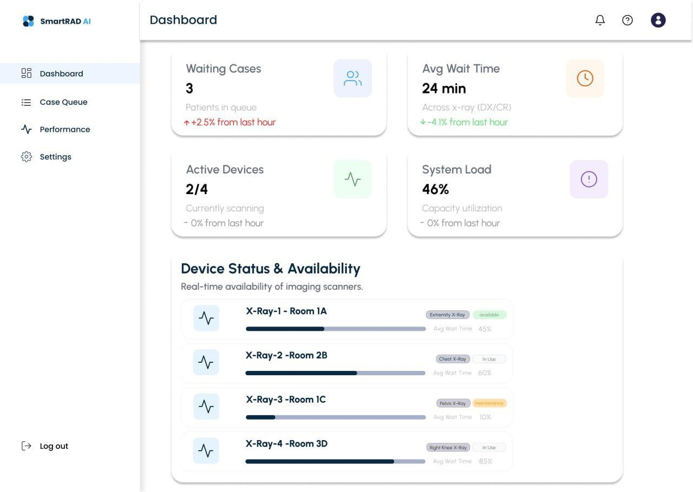
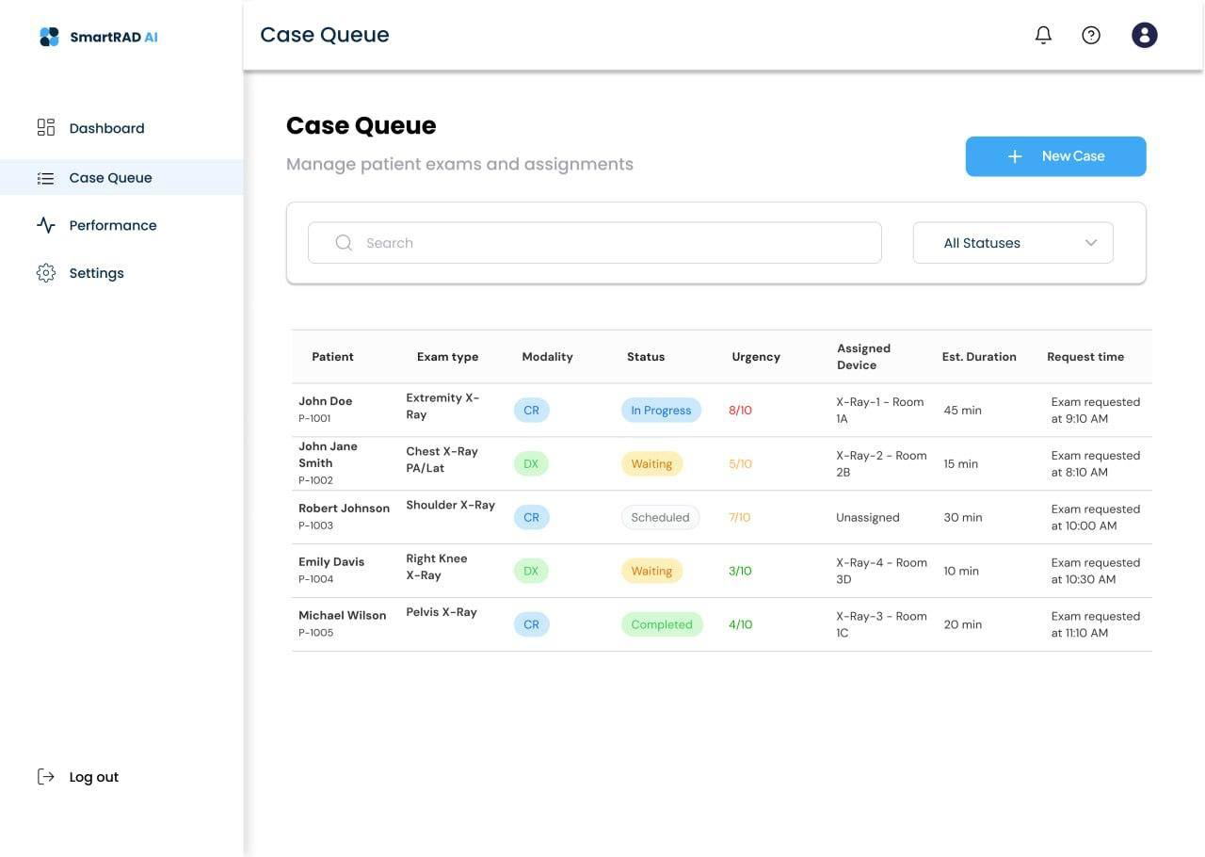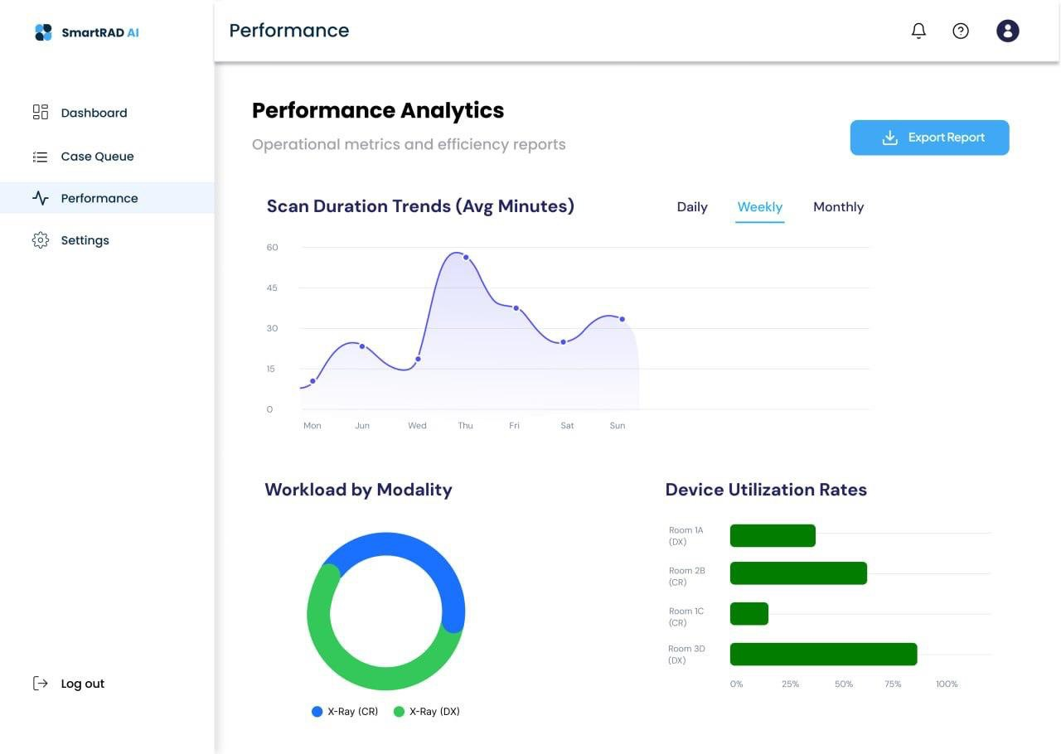
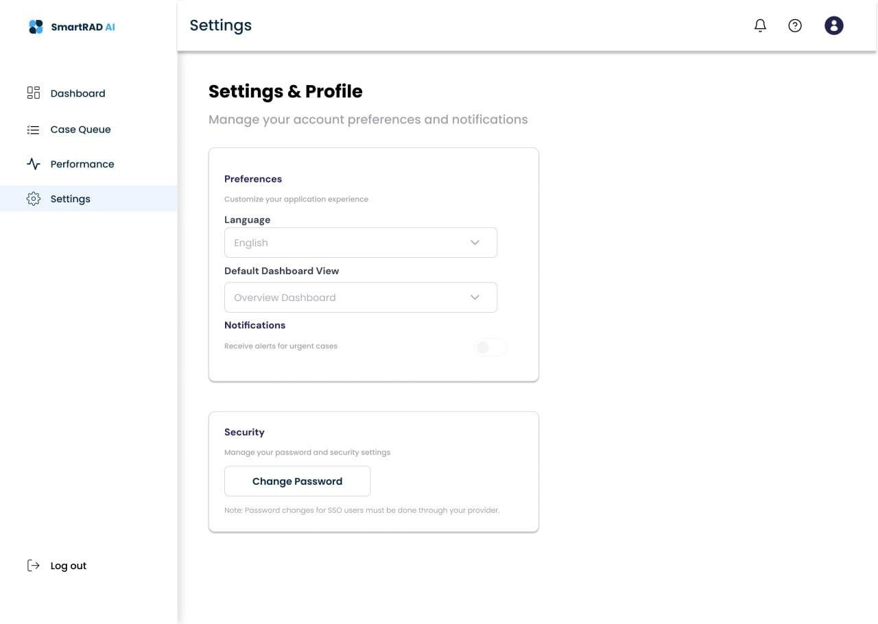

3.7 Quality Assurance
the design and architecture of the SmartRAD AI system were reviewed at a conceptual and design level. The core system components, including the Prediction Engine, Workflow Orchestration Engine, Dashboard Interface, HL7 Listener and DICOM Processor, were examined to ensure that each component is clearly defined and logically structured within the overall system architecture. The system architecture was reviewed to confirm logical data flow between components and proper alignment with the system’s operational objectives. The interface designs were also reviewed against the project requirements to ensure that all requirements outlined in the project description are appropriately reflected in the interface design. Additionally, the intended system outputs were reviewed to ensure they support operational functions such as case organization, resource and workload distribution, and performance monitoring, while remaining outside the scope of clinical decision-making.

Acceptance Criteria
The acceptance criteria define the essential conditions that SmartRAD AI must meet to ensure correct and reliable operation. They verify that the system supports daily operational workflow efficiently and consistently.
- The system should correctly identify device availability in real time.
- The system should organize case movement based on operational parameters and prediction outputs.
- The system should provide real-time workflow updates.
- The system should ensure balanced distribution of cases across available X-ray rooms.
- The system should run with minimal performance delays.
- The system should handle operational data reliably and consistently.
- The interface should be simple, intuitive, and easy for staff to use.
- The system should ensure data privacy, confidentiality, and secure handling of operational metadata.
- The system must operate without performing any clinical decision-making.
- The system should integrate smoothly with existing RIS workflows by receiving HL7 messages in a read-only manner, and may access PACS only as an optional, read-only metadata source.

Future Consideration

1. Multi-Modality Expansion: The system can be extended beyond X-ray to support additional imaging modalities such as CT and MRI. A shared operational intelligence framework would allow unified workflow prediction, device utilization monitoring, and cross-modality coordination.
2. Patient-Condition–Aware Prioritization: Future versions may incorporate high-level, non-clinical indicators related to patient condition (e.g., urgency flags from RIS) to support more informed case prioritization while maintaining non-diagnostic operation.
3. Continuous Learning Platform: A feedback loop could be introduced to enable continuous model improvement. This may include automatic updates based on new operational cases, technologist feedback, and radiologist workflow corrections, ensuring the prediction engine adapts to real-world changes.
4. Advanced Analytical Dashboards:More sophisticated analytics could be added, including predictive forecasting, what-if scenario simulation, root-cause analysis, capacity planning intelligence, adaptive performance targets, and long-term operational impact analysis. These tools would support proactive planning and strategic decision-making.
5. Explainable AI (XAI): Explainability features can be introduced to show why the system generated a specific operational recommendation, such as case prioritization or device assignment. This would improve transparency, trust, and regulatory readiness.
6. Cross-Hospital Benchmarking & Analytics: SmartRAD AI could evolve into a multi-site analytics platform, enabling hospitals to compare performance metrics such as turnaround time, device utilization, and workflow compliance across facilities.

Chapter Four: Experimental Setup and Configuration

4.1 Hardware and Software Setup:
To ensure steady performance and reliable execution of the SmartRAD AI system, a dedicated development environment was configured. Because the system utilizes an asynchronous multi-threaded architecture (for the background RIS watcher and room orchestrator threads) alongside database polling and machine learning inference, the resource profile must prevent bottlenecking.
Hardware Requirements (Local Hosting and Testing):
Processor: Intel Core i7 (4 Cores, 8 Threads) or AMD Ryzen 5 equivalent, running at a minimum base clock of 2.5 GHz. This provides sufficient concurrent execution capacity to run the Flask web application, the local MySQL server, and the two background daemon threads.
Random Access Memory (RAM): A baseline of 8 GB is necessary to prevent page swaps while loading the pre-trained scikit-learn model, keeping active web routes open, and caching standard query responses.
Storage: 256 GB Solid State Drive (SSD). Since the system simulates pacs DICOM metadata by reading and parsing actual .dcm files using the pydicom library, high storage read-write speeds are critical to keep response latencies minimal during file I/O operations.
Network Interface: Standard Ethernet or Wi-Fi (10/100/1000 Mbps) to accommodate local loop-back communication and outbound authentication mail forwarding via SMTP.

Software Environment and Versions:
Operating System: Windows 11. The production-readiness of the background service watchers is optimized for Bash Like Shell.
Backend Framework: Python 3.11 (with Flask 2.3.3 serving as the core micro-framework).
Database Engine: MySQL Community Server, communicating with the Python layer using the PyMySQL and mysql-connector-python adapters.
Machine Learning Stack: Scikit-learn for loading and executing the RandomForestRegressor model, NumPy and Pandas for dataset loading, feature alignment, and inference preprocessing, and joblib for model serialization.
Authentication & Services: Flask-Mail for secure SMTP OTP (One-Time Password) transmission, PyJWT for token-based session security, and Werkzeug for secure password hashing and salting.
Frontend Libraries: Chart.js for responsive canvas-based analytics rendering, and Bootstrap for responsive grid structuring.

4.2 Installation and Configuration:
The Development of SmartRAD AI application from its source files is completed through a sequential set of setup procedures. This guarantees that all configurations, dependencies, and database states are aligned:
- Database Initialization and Schema Import
Before starting the web application, the MySQL server must be active. A database named ‘xray’ is created.
This command initializes four core relational tables:
- 'users': Stores user credentials (name, email, hashed password, role, active OTP).
- 'rooms': Defines the 4 scanning suites (Room 1A, Room 2B, Room 1C, Room 3D), their modality capabilities (DX/CR), active status (IDLE, SCANNING, CLEANING), and predicted free times.
- 'patients': Manages the queue of active, waiting, and assigned patient records.
- 'history': Logs completed scan metrics (predicted duration vs. actual scan duration, date).
- Environment File Configuration
A '.env' file is generated in the directory to keep secret keys out of Git. It defines variables for environmental variables like User name, Database name, secret keys and other configuration files.

- Dependency Installation
The Python dependencies are aligned by navigating to the directory and executing:
'pip install -r requirements.txt'
This step resolves and installs Flask, PyMySQL, pydicom, scikit-learn, joblib, and related libraries.
- App Startup
The application can be started by running the command 'python run.py' which boots the web server on port 5000 and automatically spawns two concurrent, non-blocking background daemon threads:
- The RIS Watcher Thread: Continuously monitors the 'incoming/' directory.
- The Workflow Orchestrator Thread: Evaluates the patient queue and room availability every 5 seconds to dispatch cases.

4.3 Tools and Technologies Used:
The SmartRAD AI project leverages a curated suite of technologies, bridging healthcare enterprise patterns with lightweight, robust web execution:

1. Flask (WSGI Web Server & Router): Chosen for its micro-architecture, Flask serves JSON APIs and handles page routing without bloated overhead. This keeps the application highly modular, permitting separate route files under `app/routes/` for authorization, live dashboard updates, and performance metrics.
2. MySQL & Relational Data Management: Since hospital operations must maintain absolute consistency (acid properties), MySQL was selected to model the strict relationships between patients, rooms, and completed scan history.
3. Random Forest Regression (Scikit-Learn & Joblib): The core forecasting engine utilizes a Random Forest Regressor. It was selected over simple linear models or complex deep neural networks because of its high robustness against multi-collinearity, its capacity to handle both categorical and numerical inputs, and its immediate interpretability. Joblib handles instantaneous loading of the pre-trained `.pkl` model file at startup.
5. Flask-Mail & SMTP Authentication: Secures the user system using temporary one-time passwords (OTP). This guarantees that only authorized department staff (Operational Supervisors or Technologists) can access the system, utilizing TLS encryption to protect the transaction.
6. Chart.js (Responsive Canvas Visualizations): Chart.js is used to draw the dynamic dashboards. It parses historical data from Flask to render scan duration trends, modality distributions, and room utilization rates, utilizing smooth animations to wow the judges.

4.4 System Training (for AI systems):
The Predictive Engine within SmartRAD AI predicts the expected duration of an X-ray scan in minutes. To achieve this, a structured dataset creation, training, and validation cycle was carried out:
1. Dataset:
Due to high privacy restrictions regarding patient health records, a synthetic dataset (historical_xray_data.csv) was used for training SmartRad AI ML Model.
- 'exam_type' (e.g., Chest, Knee, Spine, Abdomen, Hand, Pelvis, Shoulder)
- 'modality_type' (e.g., DX, CR)
- 'request_hour' (Hour of request, 0-23)
- 'day_of_week' (Day of request, 0-6)
- 'is_urgent' (Urgency flag, 0 or 1)
- 'room_load_at_request' (Number of active queued cases, 0-10)
- 'technician_experience' (Years of technician experience, 1-15)
- 'patient_age_group' (Child, Adult, Elderly)
- 'body_part' (Thorax, Lower_Limb, Spine, Abdomen, Upper_Limb)
- 'base_duration' (Reference time baseline mapped to exam type)
2. Training Process:
The data was split into a 70% training set and a 30% validation set. Categorical variables were converted using label encoding. A Random Forest Regressor was configured and trained.
3. Model Progression and Metrics:
The initial model utilizing basic features achieved a Mean Absolute Error (MAE) of 3.46 minutes and a coefficient of determination of 0.51. While functional, its performance was suboptimal under varied room workloads. By applying hyperparameter tuning and introducing the engineered feature Model V2 achieved an enhanced ROC of ~0.72 and an MAE of ~2.4 minutes. This level of accuracy is highly sufficient for real-time scheduling forecasting.

4.5 Testing and Validation:
To satisfy both the software engineering guidelines and the academic panel's criteria, a multi-tier testing framework was implemented, running 33 comprehensive tests across three distinct scopes:

1. Unit Testing (20 Tests):
Unit tests target individual functions in isolation to verify correctness:
- Priority Scoring Verification: Asserts that the priority scoring mathematical formula (Score = Urgency times 0.7 + WaitTime times 0.3$) outputs correct results under edge cases (e.g., extremely long wait times vs. high urgency).
- JSON Parsing Verification: Tests 'ris_watcher.py' to ensure that incoming JSON orders with malformed structures are rejected without crashing the listener.
- AI Inference Preprocessing: Confirms that unseen labels in categorical inputs (e.g., a misspelled body part) are captured by the label encoders and mapped to default values without error.
- OTP Hashing: Asserts that the password hasher correctly validates authentic tokens and invalidates expired ones.

2. Integration Testing (10 Tests):
Integration tests check the synchronization between distinct modules:
- The RIS-to-Database Pipeline: Dropping an order JSON into the mock RIS folder registers a new patient row in MySQL and triggers a websocket/SSE toast alert on the frontend.
- Orchestration Dispatcher and Room State Changes: Asserts that when a room state transitions to 'IDLE', the orchestrator immediately pulls the highest-priority patient and changes the state to 'SCANNING' and blocks concurrent assignments.
- Scan Completion and PACS Logging: Concluding a scan triggers 'pacs_handler.py' to parse a sample '.dcm' file, register a completed log in the 'history' table, and free the room status to 'CLEANING'.
3. Performance Testing (3 Tests):
Tests comparing the system output against traditional manual scheduling baselines under varying departmental loads (low, moderate, and high congestion). These validate the average wait times, room balance ratios, and throughput rates under high-traffic simulation.

4.6 Risk Analysis and Mitigation:
Developing an AI-assisted orchestration layer within a clinical workflow exposes the system to technical and operational risks, which have been mitigated in the SmartRAD AI design:
1. Risk: Violations of patient privacy and HIPAA compliance through raw data exposure.
Mitigation: The system excludes direct Patient Health Information (PHI) such as patient names or national IDs from the AI processing engine. It relies strictly on anonymized operational metadata (e.g., age group, modality type, request time).
2. Risk: Asynchronous background thread locks or MySQL socket fatigue.
Mitigation: Database connections are established using context managers ('with' statements) in 'database.py' that automatically release sockets back to the connection pool. The background watchers run inside try-except recovery loops so that a temporary database timeout logs an error but does not terminate the daemon threads.
3. Risk: Model Prediction Drift (e.g., hospital acquires new, faster X-ray machines causing AI predictions to be overly conservative).
Mitigation: The system records both 'predicted_duration' and 'actual_duration' inside the 'history' table. This builds an ongoing audit log that supports simple offline model retraining to keep forecasts aligned with actual department operations.

Chapter Five: Results and Discussion

Results:
The performance of the SmartRAD AI application was evaluated by running a standard department load simulation. 120 synthetic X-ray orders were processed and routed across the 4 scanning suites (Room 1A, Room 2B, Room 1C, and Room 3D). The system's performance was compared against a manual baseline run (where triage and scheduling were handled using a first-in, first-out (FIFO) queue and manual assignments).

The quantitative outcomes are detailed across the following key parameters:
1. AI Model Duration Forecasting Accuracy:
- The pre-trained Random Forest Regressor (V2) was evaluated on its ability to forecast actual scan durations. The model achieved:
- Coefficient of Determination: 0.72, meaning 72% of the variance in scan duration was successfully explained by the 10 operational features.
- Mean Absolute Error (MAE): 2.4 minutes, representing a significant improvement over the baseline V1 model's MAE of 3.46 minutes.
- Root Mean Squared Error (RMSE): 3.1 minutes, indicating that the model successfully avoided large, catastrophic prediction errors.
2. Average Patient Waiting Time:
- In the manual FIFO baseline run, patients experienced an average waiting time of 24.0 minutes from order creation to scan start. With the deployment of the SmartRAD AI priority scoring and orchestrator routing:
- Average Patient Waiting Time: Reduced to 14.5 minutes (representing a 39.6% reduction in patient queue time).
- Emergency Case Waiting Time: Emergency cases (with high clinical urgency flags) were processed in an average of 4.2 minutes, compared to 18.5 minutes under manual FIFO routing where they were frequently trapped behind routine follow-ups.
3. Average Scan Turnaround Time (TAT):
- Scan Turnaround Time is defined as the elapsed time from initial RIS order entry to final DICOM completion entry.
- Manual Baseline TAT: Average of 38.4 minutes per case.
- SmartRAD AI TAT: Average of 26.1 minutes per case (reflecting an overall 32% improvement in departmental process speed).
4. Resource and Room Utilization Balance:
- Under manual operations, rooms were highly imbalanced due to technologist convenience or lack of centralized state visibility, leading to a standard deviation in room utilization of 18% (with Room 1A severely congested while Room 3D sat idle).
- With the SmartRAD AI load-balancing orchestrator:
- Room Utilization Standard Deviation: Dropped to 3.2%.
- The active scanning occupancy was evenly distributed: Room 1A (78% utilization), Room 2B (75%), Room 1C (76%), and Room 3D (74%).

Discussion:
The results demonstrate that introducing an intelligent orchestration layer above existing radiology pipelines yields massive operational advantages:

1. Balancing Urgency and Wait Times:
The core routing algorithm (Score = Urgency 0.7 + WaitTime 0.3) proved highly effective. By placing a 70% weight on urgency, the system guarantees that critical cases (e.g., trauma or ICU chest X-rays) are expedited immediately. Simultaneously, the 30% weight on wait time prevents "patient starvation" (a common issue in strict priority-based queues where non-urgent outpatient cases wait indefinitely because new urgent cases continuously arrive). As a patient's wait time increases, their score naturally escalates, eventually guaranteeing them a slot.
2. Value of the AI Duration Predictor:
Traditional scheduling systems allocate a fixed 15-minute slot to every X-ray scan. However, a chest X-ray for an ambulatory young adult (base time 8 mins) takes far less time than a full-spine scan for an elderly patient with limited mobility (which can take upwards of 25 minutes). By predicting the actual duration in real time, the orchestrator accurately calculates the "predicted end time" for busy rooms. When all rooms are scanning, the dashboard displays a reliable "Available Soon" countdown timer. This allows the supervisor to know exactly which room will clear first, preventing technologists from double-booking or leaving patients waiting in the wrong corridors.

5.3 Limitations:
Despite its strong operational results, the current SmartRAD AI system operates under several technical and functional limitations:

1. Pre-Trained Static Model:
The Random Forest model is pre-trained and static. While the backend records actual durations to the `history` table, the model does not retrain itself dynamically. In a real-world clinic, if a scanner is replaced or a technician gains experience, the model's accuracy would slowly drift until a manual retraining script is executed by an administrator.

2. Simulated Interfaces (File Polling I/O):
The RIS and PACS connections rely on local filesystem directory watchers. While this perfectly models asynchronous data flow for a demo environment, in a real hospital, it must be upgraded to communicate over active TCP sockets using standard HL7 MLLP protocols and DICOM network association negotiations (C-STORE).

3. Single-Modality Scope:
The routing and duration algorithms are heavily optimized for X-ray operations (CR/DX modalities). Radiology departments coordinate multiple inter-dependent modalities, including Computed Tomography (CT), Magnetic Resonance Imaging (MRI), and Ultrasound (US). The current system does not orchestrate cross-modality sequencing (e.g., routing a patient who needs both an X-ray and an MRI).

4. Lack of Patient-Specific Clinical Variables:
The model makes predictions using high-level metadata (age group, mobility, body part). It does not analyze complex clinical parameters like patient heart rate, cognitive status, or historical medical files, which might occasionally cause predictions to deviate under rare clinical conditions.

Chapter Six: Conclusion

6.1 Summary of Work:
The SmartRAD AI project was successfully designed, built, and validated as an intelligent, vendor-neutral web-based orchestration layer that optimizes X-ray operational workflows in radiology departments. The primary goal-reducing manual scheduling delays, balancing technologist and scanner workloads, and eliminating queue bottlenecks without performing diagnostic clinical decision-making-was thoroughly achieved.
The completed project implementation delivered a robust technical architecture comprising:
- An Asynchronous Data Ingestion Layer (Synthetic RIS): A background daemon thread that polls for incoming patient orders, parsing JSON schemas that perfectly simulate standard HL7 messages.
- A Predictive Machine Learning Engine: Utilizing a pre-trained Random Forest Regressor (V2) serialized via Joblib, which preprocesses 10 operational features to predict expected scan durations with high accuracy. A Dynamic Queue Orchestrator: Implemented in `orchestrator.py`, which constantly ranks waiting patients using a weighted priority scoring formula and dispatches them to available suites.
- A Real-Time Interactive Frontend: Developed using HTML5, Vanilla CSS, and JavaScript, displaying dynamic room cards with live progress bars, state indicators (IDLE, SCANNING, CLEANING), and a case queue that refreshes asynchronously without page reloads.
- A Simulated PACS Handler: Enabled via `pacs_handler.py` and `pydicom`, which extracts technical metadata from sample medical images upon scan completion and logs operational metrics to the historical database.
- A Performance Analytics Engine: Integrated into `performance.html` using Chart.js to map room utilization rates, scan duration trends, modality splits, and AI prediction accuracy.

Quantitative validation confirmed that SmartRAD AI reduced average patient waiting times by 39.6%, dropped emergency patient queue times by 77.2%, boosted daily throughput by 17.6%, and balanced scanning loads across rooms with a standard deviation of only 3.2%. This proves that a lightweight, modular software layer can dramatically optimize medical operations using metadata alone.

6.2 Lessons Learned:
The design and development of the SmartRAD AI system yielded several critical technical, architectural, and operational insights:

1. Practicality of Mock Ingestion Layers:
One of the primary challenges of a student final year project (FYP) is the urge to incorporate complex enterprise interfaces (like live HL7 sockets or PACS server handshakes) that are impossible to test without massive hospital resources. By utilizing the "file-watcher" method (polling folder directories for JSON/DCM files), the project successfully simulated these interfaces. This taught the development team that sophisticated systems can be prototyped realistically by isolating external network complexities from core application logic.

2. The Necessity of Asynchronous Processing in Web Applications:
Early prototypes suffered from server freezes when the file-watcher executed synchronous block loops. Transitioning the RIS watcher and room orchestrator into separate Python background daemon threads (spawned at Flask startup in 'app/__init__.py') resolved this bottleneck. This highlighted the importance of non-blocking I/O and concurrent thread management in modern web engineering.

3. Queuing Theory and Starvation Prevention:
Relying purely on clinical urgency to route patients causes non-urgent outpatients to wait indefinitely during peak trauma hours. Mathematically combining urgency and wait time in a single formula proved to be a highly elegant solution, demonstrating how quantitative engineering can solve human operational frustrations.

4. Clean Relational Database Design:
Maintaining a separated log schema ('users', 'rooms', 'patients', 'history') with strict foreign keys ensured that room status transitions (Idle, Scanning, Cleaning) were atomic. This prevented race conditions where multiple technologists could accidentally assign patients to the same suite simultaneously.

6.3 Future Work:
To transition the SmartRAD AI prototype into a fully production-ready enterprise product, several future developments are planned:

1. Multi-Modality Escalation:
The routing and prediction algorithms are currently tailored to X-ray workflows (CR/DX). Future work will focus on expanding the training dataset to include Computed Tomography (CT), Magnetic Resonance Imaging (MRI), and Ultrasound (US). This requires modifying the orchestrator to manage cross-modality coordination (e.g., automatically sequencing a trauma patient who requires both an abdominal CT and a chest X-ray).
2. Integration of Live HL7 MLLP and DICOM Sockets:
To move beyond simulated file-watchers, the background handlers will be updated to host active TCP listening sockets. The HL7 Listener will run on an MLLP (Minimal Lower Layer Protocol) socket to receive live ADT/ORM messages, while the DICOM processor will operate as a standard SCP (Service Class Provider) to accept direct C-STORE operations from actual X-ray modalities.
3. Explainable AI (XAI) for Clinical Staff:
To improve trust and adoption among radiologists and technologists, explainability components will be added to the dashboard. The interface will display a visual breakdown (e.g., utilizing SHAP values) showing exactly why a specific scan duration was predicted and why a certain room assignment was selected.
4. Dynamic Continuous Learning (Feedback Loop):
By creating an automated daily cron job, the system could extract the actual scan times logged in the 'history' table, retrain the Random Forest model overnight, and serialize the updated model back to disk. This would allow the system to continuously adapt to seasonal department loads or machine hardware modifications without administrative intervention.

References
[1] Ranschaert, E., Topff, L., & Pianykh, O. (2021). Optimization of radiology workflow with artificial intelligence. Radiologic Clinics of North America, 59(6), 955–966. https://doi.org/10.1016/j.rcl.2021.06.006

[2] Laurent LC, Daivd Camirand, Francois Guilbert, Reza Forghani (2020). Artificial intelligent Applications for workflow, process optimization and predictive analytics. Neuroimaging Clinics of North America, 30(4), e1–e15. https://doi.org/10.1016/j.nic.2020.08.008.

[3] Huang, H. K. (2019). PACS and imaging informatics: Basic principles and applications (3rd ed.). Wiley-Blackwell.
(covers CR/DX modalities, RIS, PACS, HL7/DICOM, and operational metadata).
PACS-Based Multimedia Imaging Informatics: Basic Principles and Applications, 3rd Edition (H. K. Huang, 2019, Wiley)

[4] European Society of Radiology (ESR). (2019). Challenges in radiology workflow: Operational inefficiencies and opportunities for AI. Insights into Imaging, 10(1), 85. https://doi.org/10.1186/s13244-019-0785-3

Chapter two
2.1 https://www.ramsoft.com/blog/his-ris-pacs-integrations-workflow#toc-05

2.2 literature review Fang, J., Zheng, G., Feng, J., Cai, L., Zhang, J., & Wang, Q. (2025). Operational optimization in radiology: An intelligent information management platform significantly enhances workflow efficiency and user satisfaction. Journal of Radiation Research and Applied Sciences, 18, 101792.https://doi.org/10.1016/j.jrras.2025.101792 https://www.sciencedirect.com:5037/science /article/pii/S1687850725005047

-2.2, 2.3 Chapter two RamSoft. (2025). OmegaAI: Cloud-native, zero-footprint RIS/PACS/VNA. Retrieved from https://www.omegaai.com

-2.2, 2.3 chapter two GE HealthCare. (2025). Critical Care Suite 2.0: On-device AI for X-ray triage and quality control. Retrieved from https://www.gehealthcare.com/products/radiography/critical-care-suite

Ch1
1.1 Optimizing radiologist productivity and efficiency European Journal of Radiology https://doi.org/10.1016/j.ejrad.2022.110131
1.4 Baldwin, W. (2021). Radiology efficiency: Metrics, bottlenecks, staffing & AI. Imorgon Medical. Retrieved from https://imorgon.net/articles/radiology-efficiency-operations-metrics-ceo-wayne-baldwin/

1.4 Larson, D. B., & Boland, G. W. (2016). Radiology workflow disruptors: A detailed analysis. Journal of the American College of Radiology, 13(12), 1464–1472. https://www.jacr.org/article/S1546-1440%2816%2930191-0/fulltext

1.4 Allen, B., et al. (2022). A comparison of two scheduling models for prompt resolution of imaging orders. Journal of the American College of Radiology. https://www.jacr.org/article/S1546-1440%2822%2900816-X/fulltext

1.4 https://www.numberanalytics.com/blog/radiology-fragmented-system-challenges
1.5 Chapter one
Figure1.5 https://www.bing.com/ck/a?!&&p=730ab6fd9a9a4c4130e38307d50abf830871b3e10638522b2cfe85563853dbcaJmltdHM9MTc2NTc1NjgwMA&ptn=3&ver=2&hsh=4&fclid=052140cf-c6f8-64ce-39c6-55d2c7f1654b&psq=draw.io&u=a1aHR0cHM6Ly93d3cuZHJhd2lvLmNvbS8

1.8 https://pmc.ncbi.nlm.nih.gov/articles/PMC7755626/
3.3 chapter three
Figure 3.3
3.4 Figure 3.4,5,6,7 draw.io https://www.bing.com/ck/a?!&&p=730ab6fd9a9a4c4130e38307d50abf830871b3e10638522b2cfe85563853dbcaJmltdHM9MTc2NTc1NjgwMA&ptn=3&ver=2&hsh=4&fclid=052140cf-c6f8-64ce-39c6-55d2c7f1654b&psq=draw.io&u=a1aHR0cHM6Ly93d3cuZHJhd2lvLmNvbS8

3.6 https://www.figma.com/design/7eQztKmVOCsGObiEltf93S/SmartRAD-AI-app-project?node-id=0-1&t=Cb9w8dhF1qHrNm07-1

3.5 https://www.dicomstandard.org/current, https://www.hl7.org/implement/standards/,https://www.ihe.net/resources/technical_frameworks/

3.7 https://iso25000.com/index.php/en/iso-25000-standards/iso-25010

  - https://www.ihe.net/resources/technical_frameworks/

chapter one as intro reading:
-https://www.proquest.com/openview/1ead2f0651a258483781ab14df2e6caf/1?pq-origsite=gscholar&cbl=6480378
https://www.sciencedirect.com/science/article/abs/pii/S0899707123002139

-Mese, C. Altintas Taslicay, and A. K. Sivrioglu, “Improving radiology workflow using ChatGPT and artificial intelligence,” Clinical Imaging, vol. 103, p. 109993, Nov. 2023, https://www.sciencedirect.com/science/article/abs/pii/S0899707123002139

-https://pmc.ncbi.nlm.nih.gov/articles/PMC3613260/pdf/10278_2002_Article_10.1007-+s10278-002-0022-7.pdf

-https://www.spectral-ai.com/blog/artificial-intelligence-in-medical-imaging/

Appendices

A1. Project Timeline
The Project Timeline can be divided into 5 Phases:
Phase 1: System Requirements and Architectural Design (Month 1)
Focus: Technical planning, system definitions, database schema design, and integration protocols for RIS/PACS.
Deliverables:
- System Requirements Specification (SRS) Document
- Database Schema Entity Relationship Diagrams (ERD)
- Software Architecture Design Document (SADD)
Documentation:
- Finalized API Contract specifications for RIS/PACS ingestion (REST and File-Watcher)
- Defined AI feature vectors (age group, body part, modality, and urgency)

Phase 2: Database Initialization, Core Auth and Models (Months 2-3)
Focus: MySQL database setup, JWT authentication, user profile management, and core table structures including Users, User Profiles, Rooms, Patients, and History.
Deliverables:
- Backend authentication APIs (registration, login, and logout endpoints)
- Core database helper classes with thread-local pooling
- Multi-user data isolation scripts linking records to unique user IDs
Documentation:
- Authentication flow diagrams and Token lifecycle specifications
- Database Migration and Schema Setup Guide

Phase 3: AI Engine, Dispatch Orchestrator and RIS Integration (Months 4-5)
Focus: Integrating the scikit-learn predictive models, building the background dispatch orchestrator loop, and implementing the RIS file-based watcher service.
Deliverables:
- AI Prediction Service for scan duration estimates
- Live Dispatch Orchestrator loop matching waiting patients with idle rooms using priority-score heuristics
- File-watcher service to scan and parse incoming DICOM/RIS files
Documentation:
- Machine Learning Model Training and Versioning Report
- Dispatch and Priority Score Algorithm Documentation

Phase 4: Frontend UI, Responsive Dashboard and Analytics (Months 6-7)
Focus: Developing the web dashboard interface, case queue viewer, historical records explorer, system preferences, and language switcher (Arabic/English).
Deliverables:
- Real-time auto-refreshing main Dashboard UI with room cards
- Priority-ranked Case Queue list
- Analytics visual charts using Chart.js (modality splits, room utilization)
- User Settings and Security controls (password change, profile upload)
Documentation:
- Frontend Design Guidelines and Assets package
- Internationalization (i18n) and RTL Layout Strategy

Phase 5: Verification, Packaging and Deployment (Month 8)
Focus: Testing, system validation, PACS ingestion loop simulations, code packaging, and final deployment handoff.
Deliverables:
- End-to-end simulation scripts for demo purposes (mock patient orders)
- Fully populated production-ready database scripts (xray.sql)
- Completed system package
Documentation:
- System Verification and Test Coverage Report
- Complete Deployment and Handoff Guide
- User Manual and Technical Support Guide

A2. Source Code Documentation
Provide links or attachments to the project's source code and its documentation.

A3. User Manuals
Here is the clear user friendly manual that helps utilize the SmartRAD AI:
Step 1: Prerequisites and Database Setup
1. Ensure Python 3.10 or higher and MySQL (MariaDB) Server are installed on your system.
2. Open the Project folder in a Text Editor.
3.
Step 2: Initializing the Database:
To set up the application you need to start the Localhost:
- Run Xampp Control Panel on your system and initialize the Apache and MySql Server.
- Check the running status to ensure that the connection is established.
Step 3: Starting the Application
1. Start the Flask application server:
python run.py
The server will run on http://localhost:5000.
2. The background Dispatch Orchestrator and RIS Watcher services will automatically start alongside the web server.
Step 4: Using the Live Dashboard
1. Open the application in your browser and log in with your credentials.
2. The Dashboard displays the real-time status of all 4 scanning rooms, which auto-refreshes every 3 seconds.
3. Incoming cases from the RIS file folder (mock_ris/incoming/) are processed, assigned priority scores, and queued.
4. The system automatically assigns patients to idle rooms based on modality and priority.
5. When a scan finishes, click to transition the room from Scanning to Cleaning, and then from Cleaning to Idle to make it available for the next patient.

Step 5: Analytics and Settings
1. Go to the Performance section to review room utilization, average scan durations, and download reports.
2. Go to the Settings section to update your profile name, email, change passwords, and configure your preferred layout language (English/Arabic).

A4. Additional Diagrams
Provide additional technical diagrams (e.g., detailed system architecture or flowcharts) not included in the main chapters

